1. CREATE DATABASE
MongoDB Query:
use BCA
Explanation: Creates or switches to the BCA database.
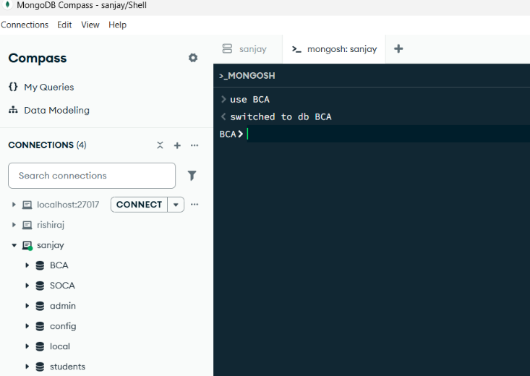
2. CREATE COLLECTION
MongoDB Query:
db. create Collection("BCA")
Explanation: Creates a collection named BCA.
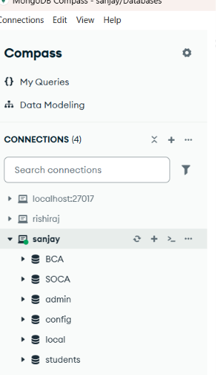

3. INSERT 50 STUDENTS
MongoDB Query:
db. BCA. Insert Many([ ])
[{"roll_no":1,"name":"Vihaan Mehta","age":18,"marks":78,"city":"Mumbai","email":"vihaan.mehta01@example.com"},
{"roll_no":2,"name":"Diya Malhotra","age":19,"marks":92,"city":"Pune","email":"diya.malhotra02@example.com"},
{"roll_no":3,"name":"Kabir Bansal","age":20,"marks":85,"city":"Chandigarh","email":"kabir.bansal03@example.com"},
{"roll_no":4,"name":"Meera Nair","age":18,"marks":74,"city":"Kochi","email":"meera.nair04@example.com"},
{"roll_no":5,"name":"Reyansh Mehta","age":19,"marks":89,"city":"Ahmedabad","email":"reyansh.mehta05@example.com"},
{"roll_no":6,"name":"Myra Desai","age":20,"marks":96,"city":"Surat","email":"myra.desai06@example.com"},
{"roll_no":7,"name":"Dhruv Chatterjee","age":21,"marks":68,"city":"Kolkata","email":"dhruv.chatterjee07@example.com"},
{"roll_no":8,"name":"Anika Menon","age":18,"marks":83,"city":"Bengaluru","email":"anika.menon08@example.com"},
{"roll_no":9,"name":"Ishaan Bhatia","age":19,"marks":77,"city":"Amritsar","email":"ishaan.bhatia09@example.com"},
{"roll_no":10,"name":"Tara Mukherjee","age":20,"marks":91,"city":"Kolkata","email":"tara.mukherjee10@example.com"},
{"roll_no":11,"name":"Ayaan Oberoi","age":18,"marks":72,"city":"Gurugram","email":"ayaan.oberoi11@example.com"},
{"roll_no":12,"name":"Kiara Dutta","age":19,"marks":87,"city":"Bhubaneswar","email":"kiara.dutta12@example.com"},
{"roll_no":13,"name":"Arnav Sethi","age":20,"marks":94,"city":"Noida","email":"arnav.sethi13@example.com"},
{"roll_no":14,"name":"Avni Menon","age":18,"marks":81,"city":"Chennai","email":"avni.menon14@example.com"},
{"roll_no":15,"name":"Shaurya Arora","age":21,"marks":69,"city":"Amritsar","email":"shaurya.arora15@example.com"},
{"roll_no":16,"name":"Ira Kulkarni","age":19,"marks":90,"city":"Pune","email":"ira.kulkarni16@example.com"},
{"roll_no":17,"name":"Atharv Patil","age":18,"marks":76,"city":"Nashik","email":"atharv.patil17@example.com"},
{"roll_no":18,"name":"Navya Iyer","age":20,"marks":88,"city":"Chennai","email":"navya.iyer18@example.com"},
{"roll_no":19,"name":"Rudra Bhatt","age":19,"marks":73,"city":"Dehradun","email":"rudra.bhatt19@example.com"},
{"roll_no":20,"name":"Mahika Reddy","age":18,"marks":95,"city":"Hyderabad","email":"mahika.reddy20@example.com"},
{"roll_no":21,"name":"Pranav Bose","age":20,"marks":84,"city":"Kolkata","email":"pranav.bose21@example.com"},
{"roll_no":22,"name":"Aarohi Pillai","age":19,"marks":79,"city":"Thiruvananthapuram","email":"aarohi.pillai22@example.com"},
{"roll_no":23,"name":"Vedant Joshi","age":21,"marks":66,"city":"Nagpur","email":"vedant.joshi23@example.com"},
{"roll_no":24,"name":"Sia Kapoor","age":18,"marks":93,"city":"Mumbai","email":"sia.kapoor24@example.com"},
{"roll_no":25,"name":"Yuvan Rao","age":20,"marks":82,"city":"Hyderabad","email":"yuvan.rao25@example.com"},
{"roll_no":26,"name":"Rhea Fernandes","age":19,"marks":86,"city":"Goa","email":"rhea.fernandes26@example.com"},
{"roll_no":27,"name":"Lakshya Anand","age":18,"marks":71,"city":"Patna","email":"lakshya.anand27@example.com"},
{"roll_no":28,"name":"Aadhya Shetty","age":20,"marks":89,"city":"Mangaluru","email":"aadhya.shetty28@example.com"},
{"roll_no":29,"name":"Kiaan Choudhary","age":19,"marks":80,"city":"Jaipur","email":"kiaan.choudhary29@example.com"},
{"roll_no":30,"name":"Esha Sood","age":18,"marks":97,"city":"Shimla","email":"esha.sood30@example.com"},
{"roll_no":31,"name":"Raghav Thakur","age":21,"marks":75,"city":"Chandigarh","email":"raghav.thakur31@example.com"},
{"roll_no":32,"name":"Samaira Roy","age":19,"marks":90,"city":"Kolkata","email":"samaira.roy32@example.com"},
{"roll_no":33,"name":"Naksh Jain","age":20,"marks":78,"city":"Indore","email":"naksh.jain33@example.com"},
{"roll_no":34,"name":"Anvi Ranganathan","age":18,"marks":85,"city":"Coimbatore","email":"anvi.ranganathan34@example.com"},
{"roll_no":35,"name":"Parth Trivedi","age":19,"marks":70,"city":"Vadodara","email":"parth.trivedi35@example.com"},
{"roll_no":36,"name":"Zoya Mirza","age":20,"marks":92,"city":"Srinagar","email":"zoya.mirza36@example.com"},
{"roll_no":37,"name":"Krish Malviya","age":18,"marks":83,"city":"Bhopal","email":"krish.malviya37@example.com"},
{"roll_no":38,"name":"Aisha Thomas","age":19,"marks":88,"city":"Kochi","email":"aisha.thomas38@example.com"},
{"roll_no":39,"name":"Ronav Kapoor","age":21,"marks":64,"city":"Delhi","email":"ronav.kapoor39@example.com"},
{"roll_no":40,"name":"Ishita Ghosh","age":20,"marks":91,"city":"Ranchi","email":"ishita.ghosh40@example.com"}
]
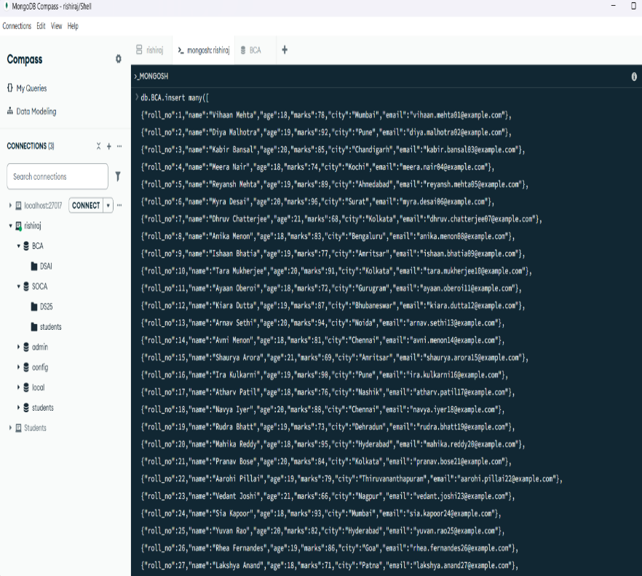

Explanation: Inserts multiple student documents into the collection.

4. DISPLAY ALL STUDENTS
MongoDB Query:
db. BCA. Find ()
Explanation: Retrieves documents from the BCA collection.
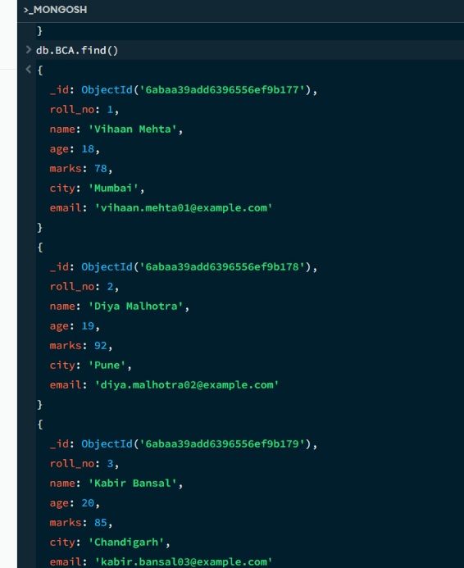

5. EQUAL TO — $eq
MongoDB Query:
db. BCA. Find ({marks: {$eq: 90}})
Explanation: Finds students whose marks are exactly 90.
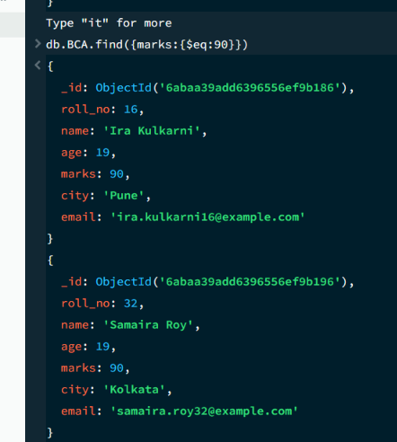

6. GREATER THAN — $gt
MongoDB Query:
db.BCA.find({marks: {$gt: 90}})
Explanation: Finds students whose marks are greater than 90.
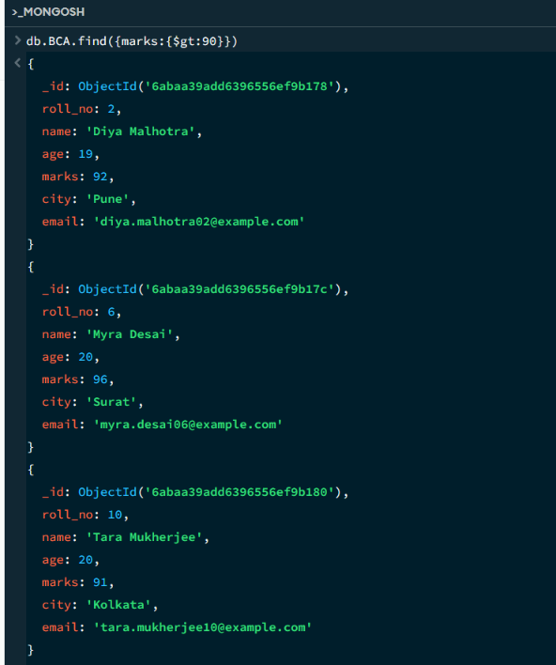

7. LESS THAN — $lt
MongoDB Query:
db. BCA. find ({marks: {$lt: 70}})
Explanation: Finds students whose marks are less than 70
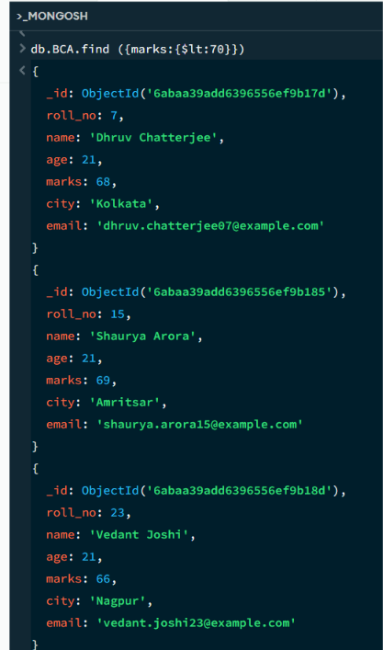

8. GREATER THAN OR EQUAL TO — $gte
MongoDB Query:
db. BCA. find({marks: {$gte: 90}})
Explanation: Finds students whose marks are 90 or above
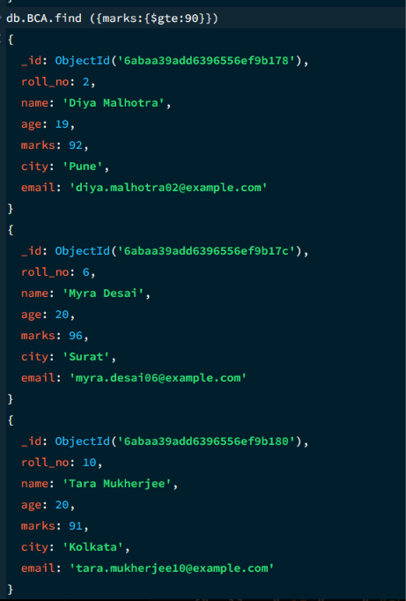

9. LESS THAN OR EQUAL TO — $lte
MongoDB Query:
db. students. find({marks: {$lte: 70}})
Explanation: Finds students whose marks are 70 or below
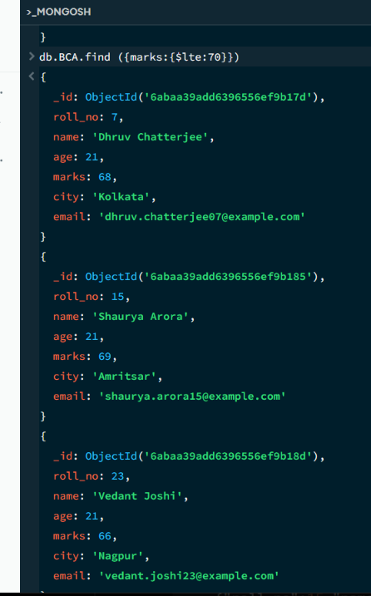
11. DELETE ONE OPERATION
MongoDB Query:
db.BCA.deleteOne({roll:10})
Explanation: Deletes one document matching roll number 10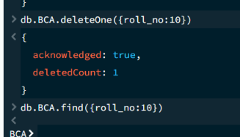
12. DELETE MANY OPERATION
MongoDB Query:
db.BCA.deleteMany({
marks: {$lt:70}
})
Explanation: Deletes all students having marks below 70.
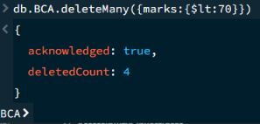
13. AND OPERATION — $and
MongoDB Query:
db. BCA. find({
$and:[
{marks:{$gt:80}},
{age:19}
]
})
Explanation: Finds students satisfying both conditions.
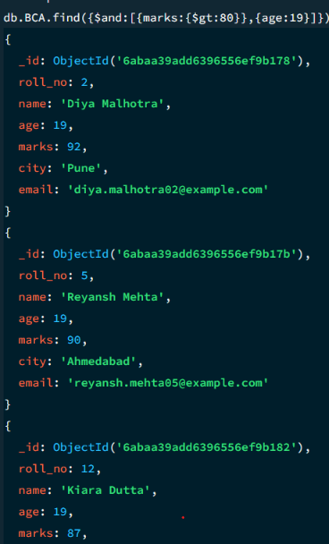
14. OR OPERATION — $or
MongoDB Query:
db.students.find({ $or:[ {city:"Mumbai"}, {city:"Kolkata"} ] })
Explanation: Finds students from Mumbai or Kolkata
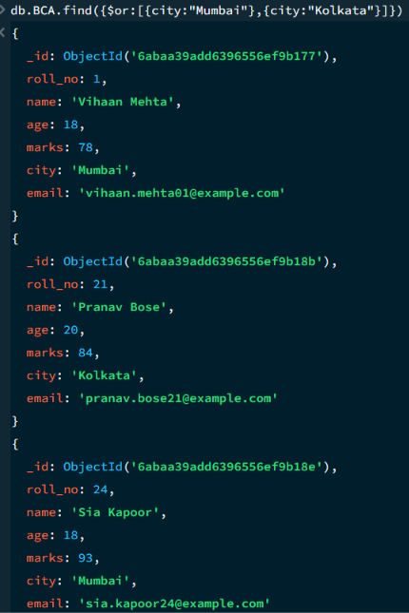
15. SORT OPERATION
A.MongoDB Query:
db. BCA. find (). sort({marks : 1})
Explanation: Sorts students by marks from lowest to highest. Use 1 for ascending order.
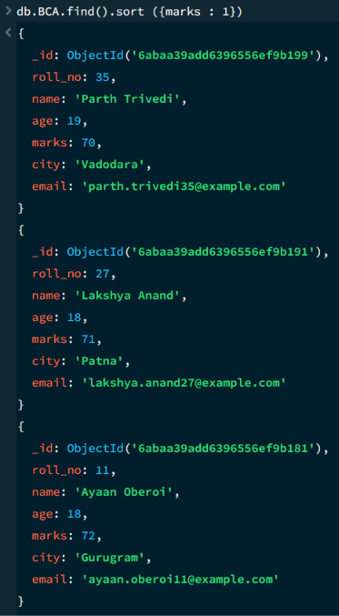
B. MongoDB Query:
db. BCA. find (). Sort ({marks: -1})
Explanation: Sorts students by marks from highest to lowest. Use -1 for descending order.
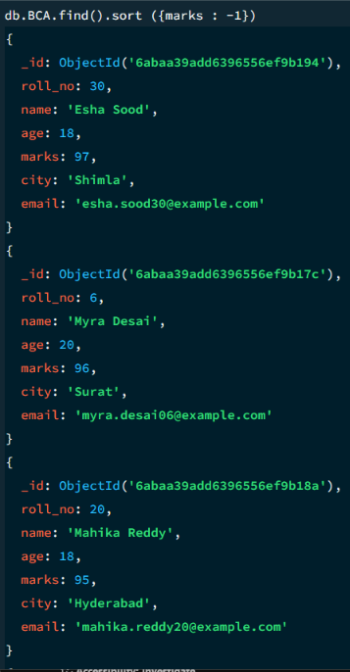
16. LIMIT OPERATION
MongoDB Query:
db. BCA. find (). limit (5)
Explanation: Displays only the first five documents.
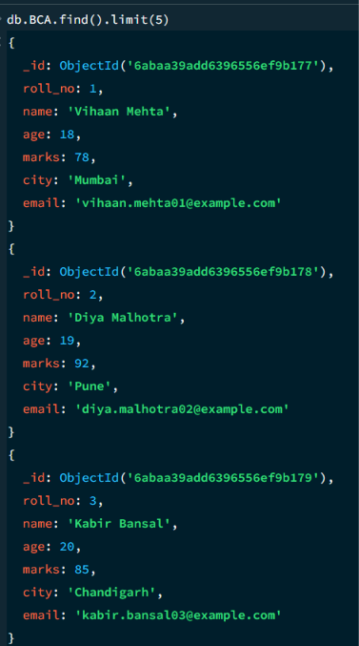
17. SEARCH BY CITY
MongoDB Query:
db.BCA.find({city:"Pune"})
Explanation: Finds all students whose city is Pune.
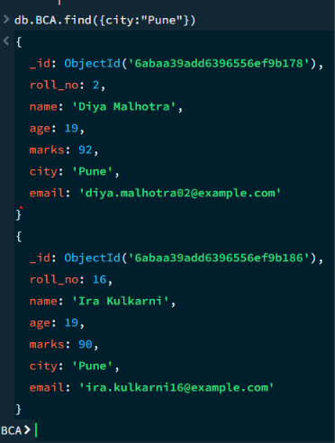
18. COUNT DOCUMENTS
MongoDB Query:
db. BCA. count Documents ()
Explanation: Counts documents currently present in the collection (performing after the delete function).
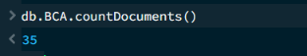

MONGODB OPERATORS USED:

Operator | Meaning | Example
$eq | Equal to | marks: {$eq:88}
$gt | Greater than | marks: {$gt:85}
$lt | Less than | marks: {$lt:60}
$gte | Greater than or equal to | marks: {$gte:90}
$lte | Less than or equal to | marks: {$lte:70}
$and | All conditions true | $and:[...]
$or | At least one condition true | $or:[...]

